Learning Aim A: Investigate data modelling and how it can be used in the decision-making process.

How to enter data into a cell
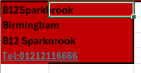
I have gone to enter the data into the following cololums such as addresses and telephone number in the excel

How to edit data into a cell
Formatting data
Explain the purpose of formatting data in an Excel spreadsheet.

How to add colour to a cell
Create step by step instructions with screenshots on how to add colour to a cell.
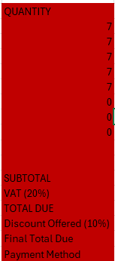
As I have proceeded to do this I went on to highlight the boxes around and clicked on the following colour and press shade so therefore It turns red

How to add borders to a cell
Create step by step instructions with screenshots on how to add borders to a cell.
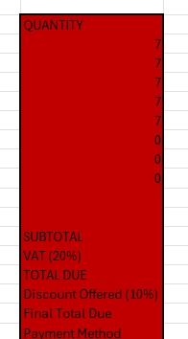
I went to shade on my boxes and clicked onto press the format box and going onto press all borders making it all black all around

How to format text in a cell
I highlighted on the following text and press on fonts to find all styles and made it ariel bold making the text thicker
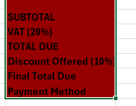
How to format numbers in a cell
I highlighted on the following Number and press on currencies to find all styles and made it ariel bold making the text thicker

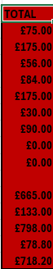

How to conditional format cells
Create step by step instructions with screenshots on how to conditional format cells.
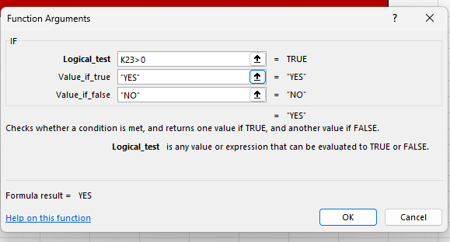
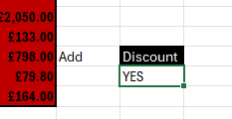
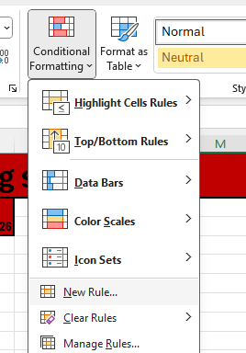
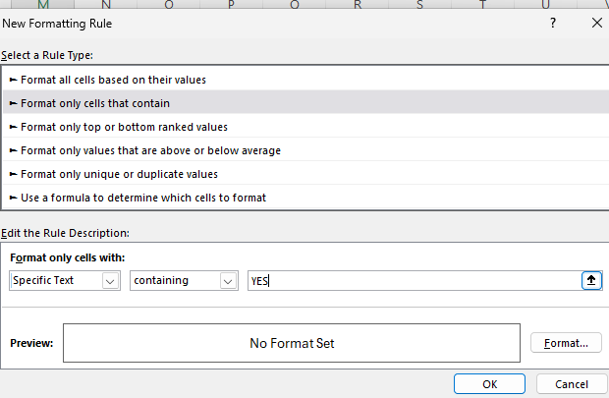
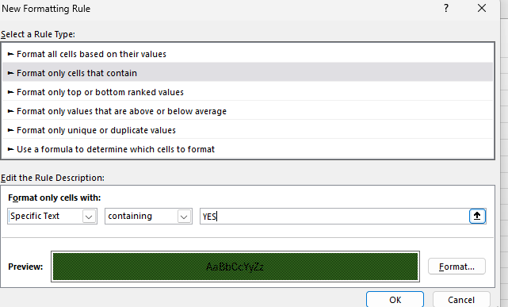
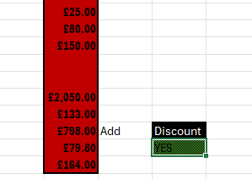
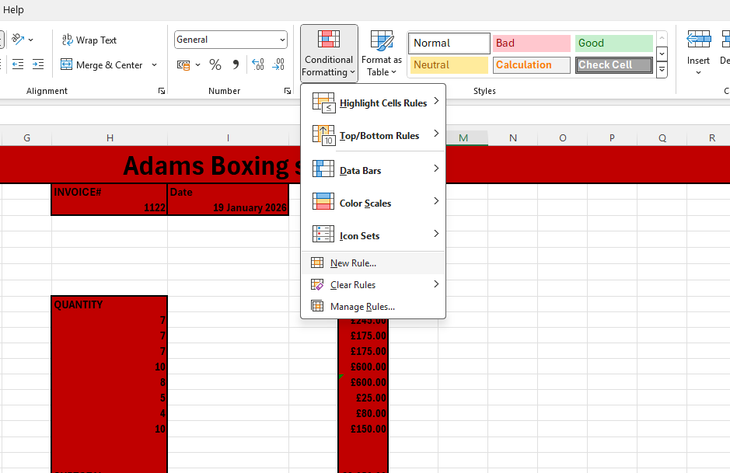
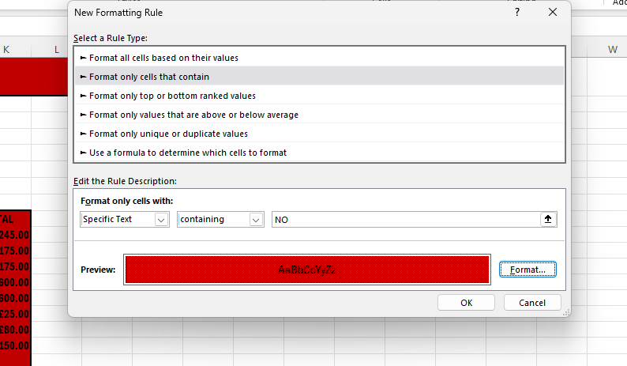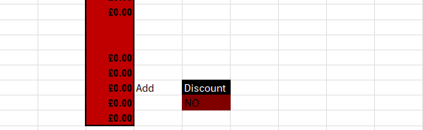

Using formulae and functions
Explain the purpose of using formulas and functions in an Excel spreadsheet.

How to use the add, subtract, multiply, division formula
Choose TWO formula from the list below and then create step by step instructions with screenshots on how to apply that formula:

- Add
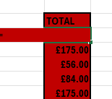
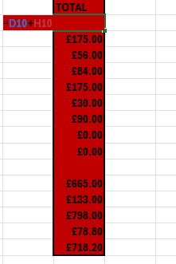
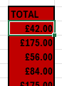

- Multiply
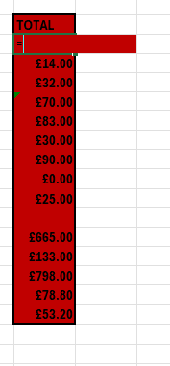
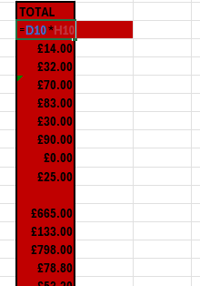
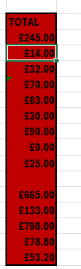

Create step by step instructions with screenshots on how to use the add formula.

How to create a SUM function
Create step by step instructions with screenshots on how to create a SUM function.
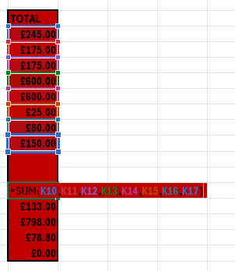

How to create an AVERAGE function
Create step by step instructions with screenshots on how to create an AVERAGE function.
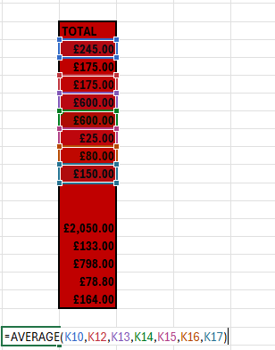

All these calculations help the business flow in a good way allowing them to combine their total costs such as unit and quantity and vat 20 percent if you times it by 0.10 or 0.20 it will be reduced in 20 percent average witch helps them overall calculate all the prices with functions

Validation and verification of data
Explain the purpose of using validation and verification tools in an Excel spreadsheet.

How to create a drop-down list in a cell
Create step-by-step instructions with screenshots on how to create a drop-down list in a cell.
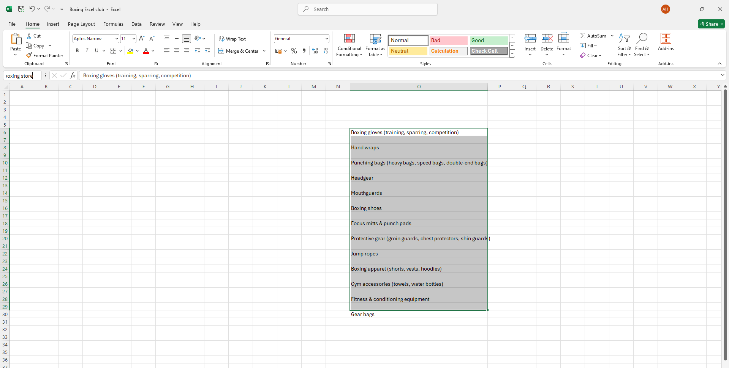
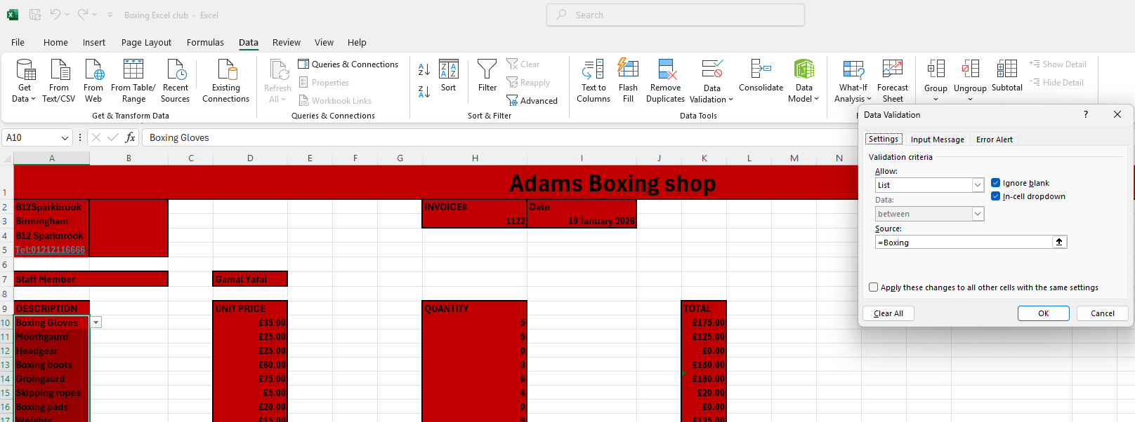
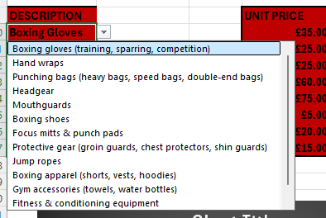
How apply data validation to inputted data with an error message to a cell
Create step by step instructions with screenshots on how to apply data validation to inputted data with an error message to a cell.

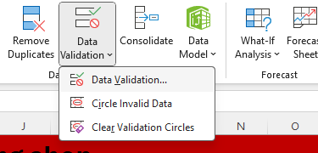
One of the ways that data validation is so that you do not type something wrong in the table drop down just in case you type something that is not matched with data validation

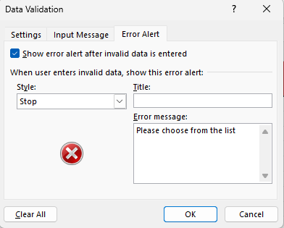

How to verify data using the IF function
Create step by step instructions with screenshots on how to verify data using the IF function.
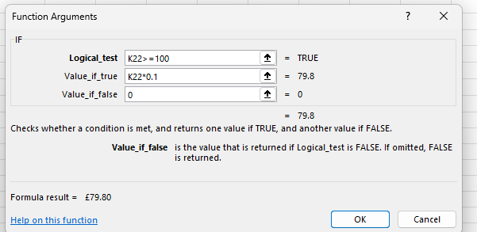
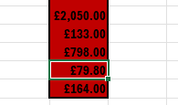

Analysing and interpreting data
Explain the purpose of using analysing and interpreting tools in an Excel spreadsheet.

How to organise data using the Sort option
Create step by step instructions with screenshots on how to organise data using the Sort option.
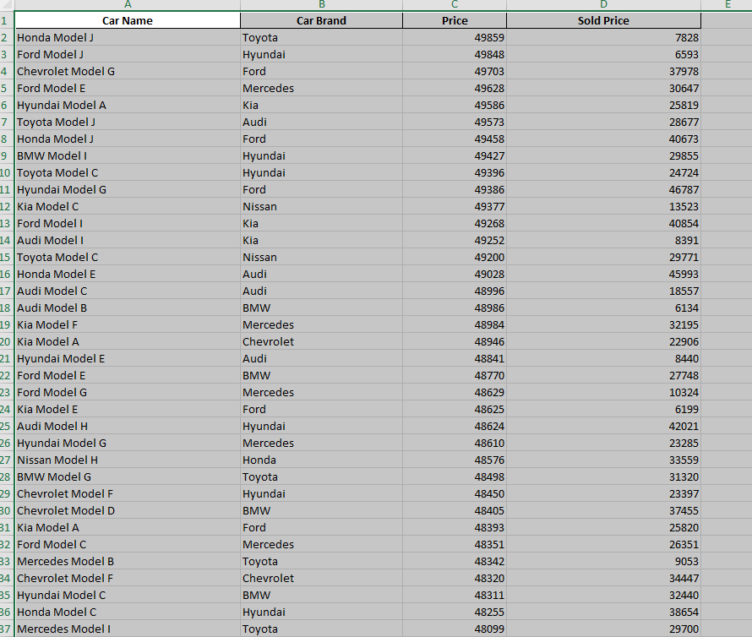
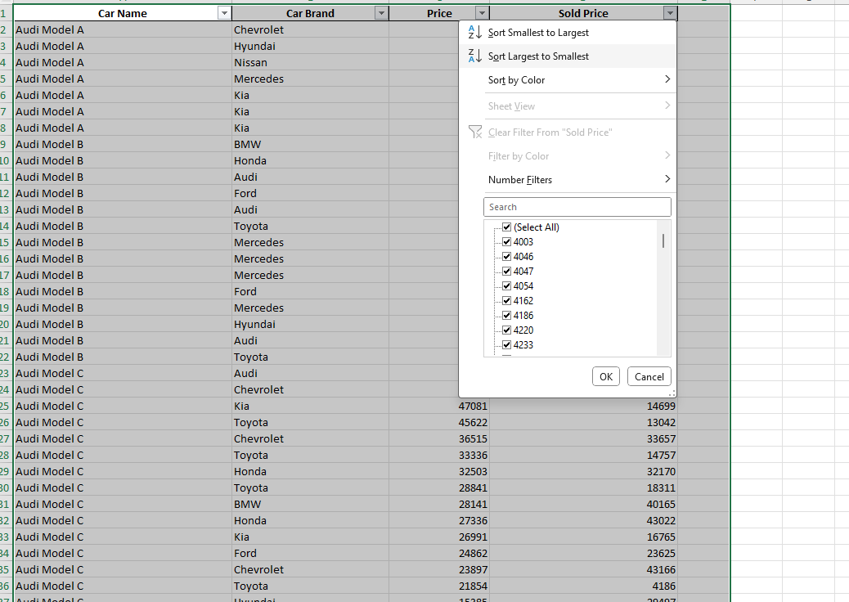
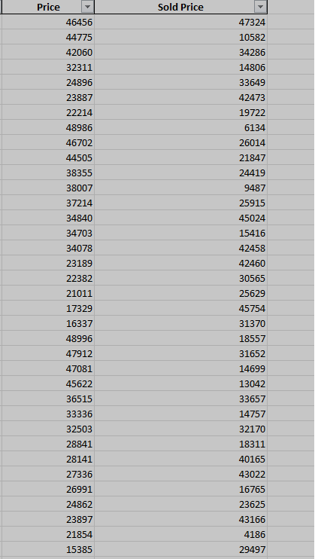

How to organise data using the Filter options
Create step by step instructions with screenshots on how to organise data using the Filter options.

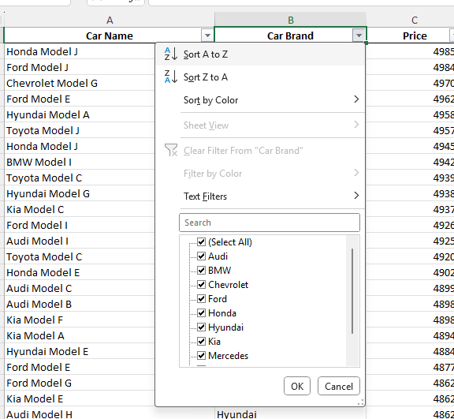
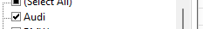
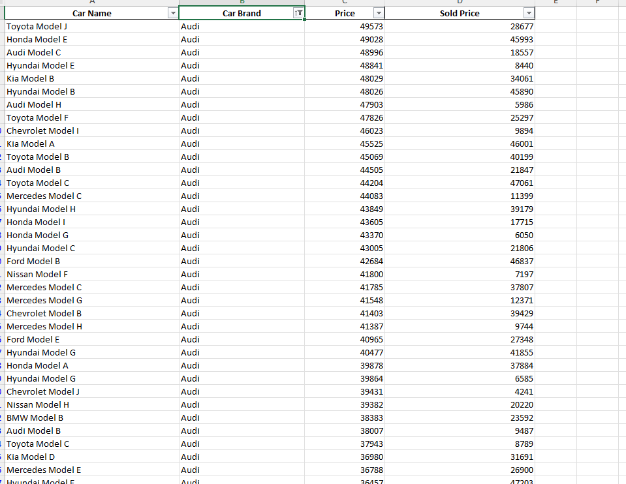
This helps the business find a certain category for example in the screenshot it shows that I have only shown Audi so therefore this helps businesses create an easy option to find what you are looking for

Presenting data
Explain the purpose of using tools to help present data in an Excel spreadsheet.

How to create a Line graph, Pie chart or Bar chart
Choose TWO options to present data from the list below and then create step by step instructions with screenshots on how to create them:
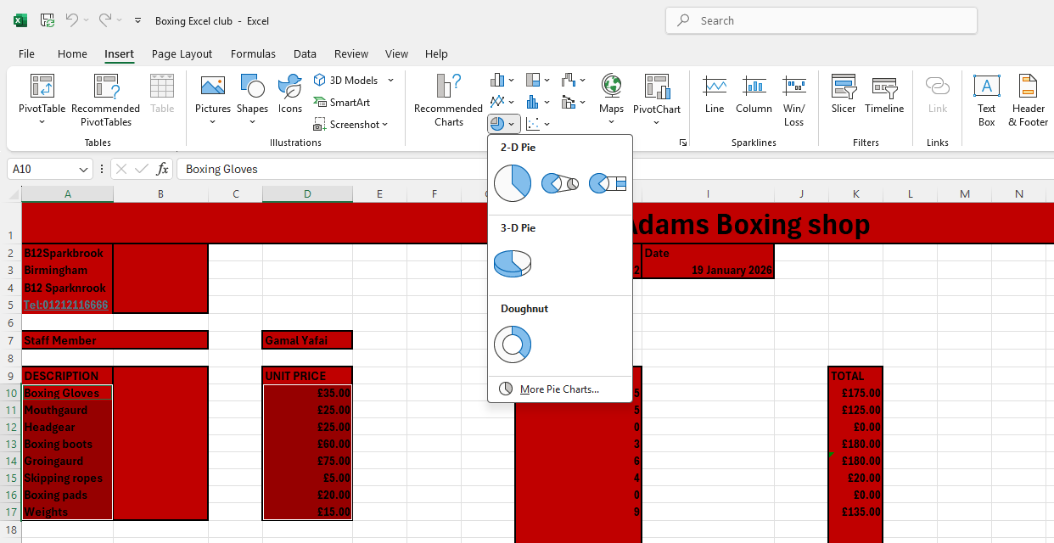
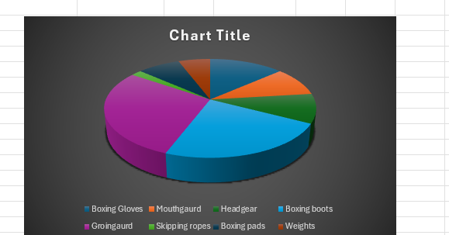

- Line Chart
- Bar Chart- Show £
- Pie Chart- Show %

The way bar charts can help businesses is the flow of the unit prices quantity and

Advanced spreadsheet features and Functions

valuate the use of advanced features and functions of a spreadsheet in data modelling and clearly explain how this contributes to the decision-making process. Checking if stock goes up or down and with that it manges the business very well and making all the quantity even

Functions and Formulae
make sure you include examples of this of each point you make, for example how might a business use these features to make a decision.
One paragraph for these features
- Average
- Min/max
- Sum function
One paragraph for these features
- If Function
- Conditional formatting

Validation and Verification of data
- Data validation
- Validation rules
- Error messages

Analysing and Interpreting data
- Filter- filter out different categories or options
- Sort- a-z, low to high

Presenting Data
- Charts

